INDIAN INSTITUTE OF TECHNOLOGY KHARAGPUR



Department of Electronics & Electrical Communication

Engineering

M.Tech. First Year

Vision and Intelligent Systems

(VIS)

EC60064-Biomedical System Engineering and Automation

Assignment 3

Submitted by

Suraj Kumar

Roll No. = 22EC65R14

**Question 1**

Write a Python program to compute the RMS value at each instant for the EMG signal in the file emg.txt by using a causal short-time analysis window of duration in the range of 50 - 150 ms. Use two different window durations and two different window shapes (a rectangular window and a Hanning window that is given by w[n] = 0.5 - 0.5*cos(2*pi*n/(N-1)) where w[n] is the value of the window at sample index n, N is the length of the window and pi is the mathematical constant that is approximate to 3.14159) and analyze the results

**Outputs**

1. First the original image was extracted and plotted

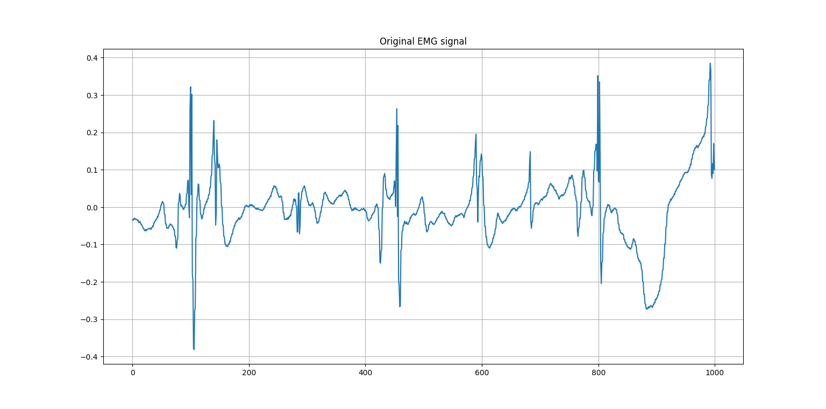

1. Then the signal was padded with zeroes from front
2. And then using suitable window the RMS value at each point is calculated.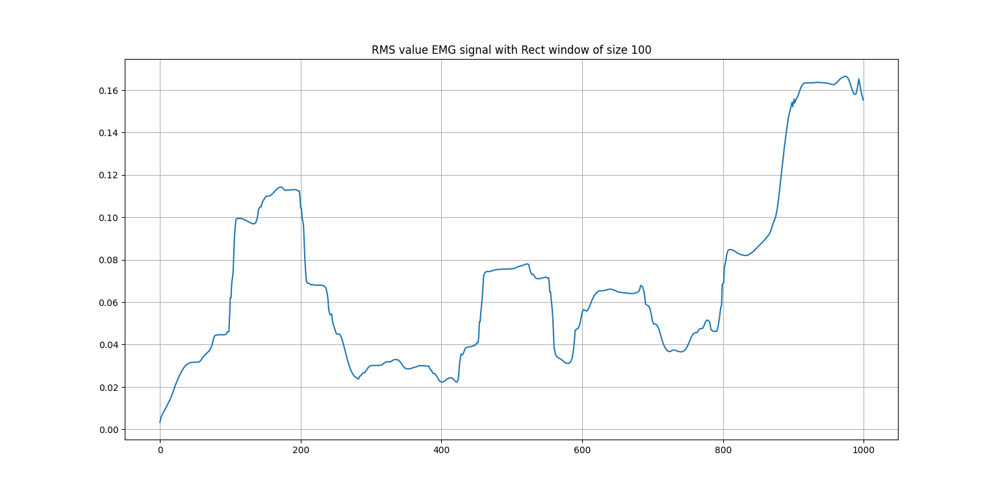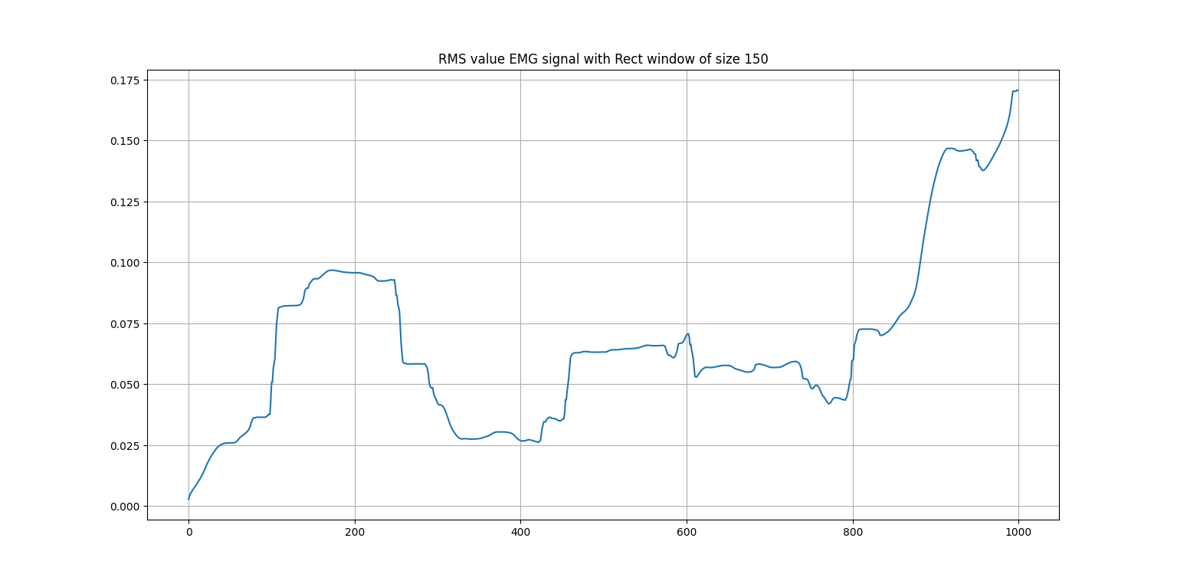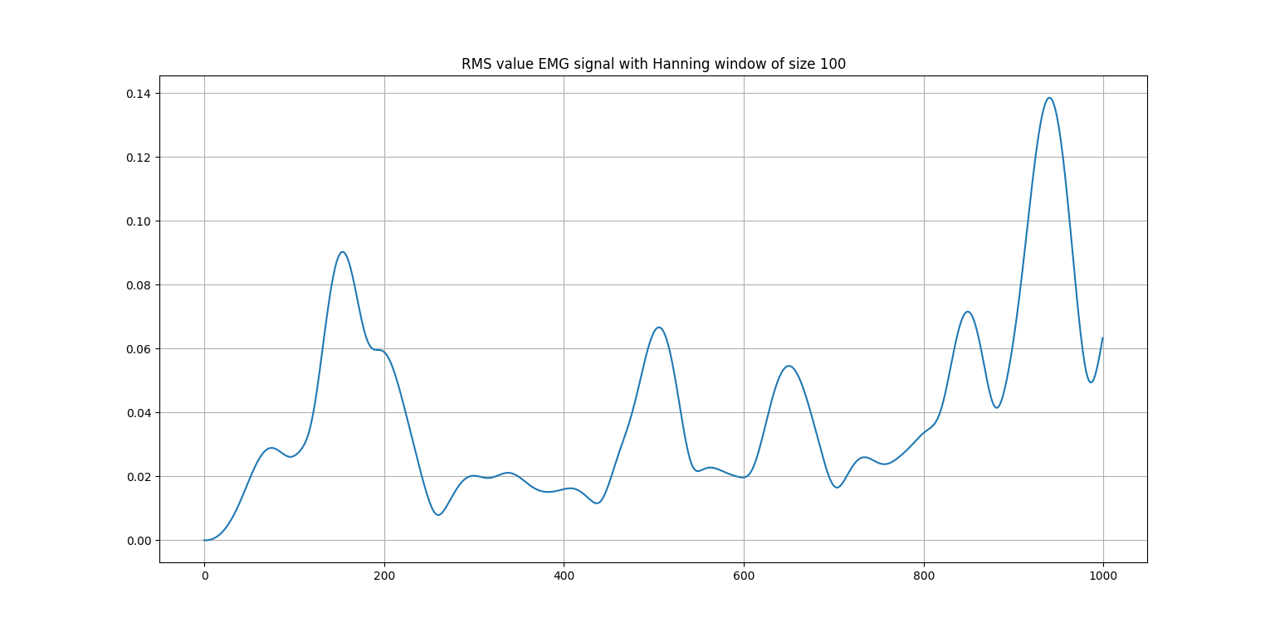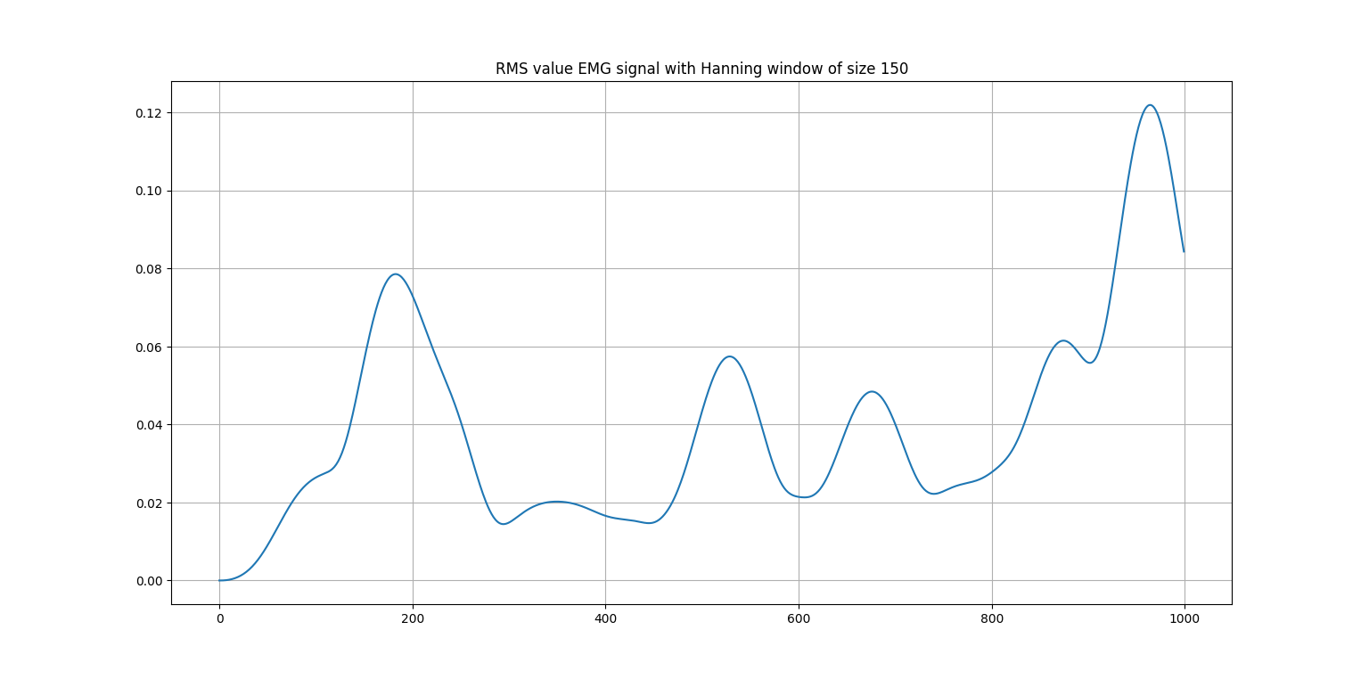

**Observations**

1. Hanning filter gives more smooth output
2. Smoothness increases with increase in window size
3. Hanning window is used for reducing the spectral leakage.

**Question 2**

Develop a program to derive the envelogram using complex demodulation by Sarkady. Apply the procedure to the PCG signals in the file pec1.mat, pec33.mat, pec52.mat.

Extend the procedure to average the envelograms over several cardiac cycles using the ECG as the trigger. How will we handle the variations in the duration (number of samples) of the signals from one beat to another?

**Outputs:**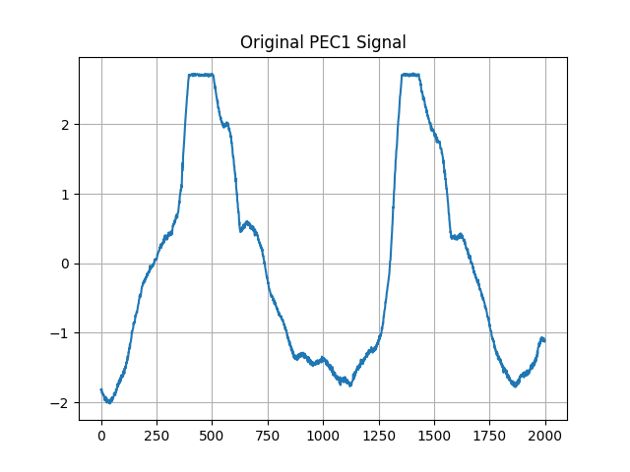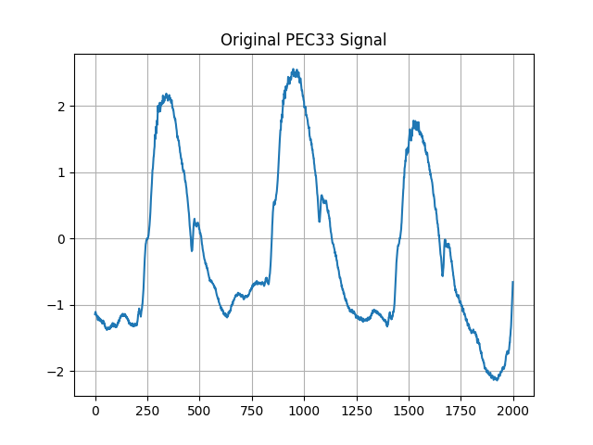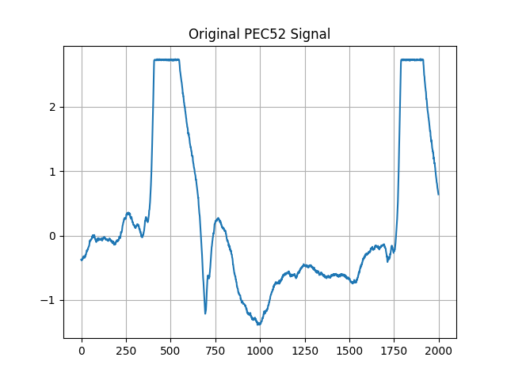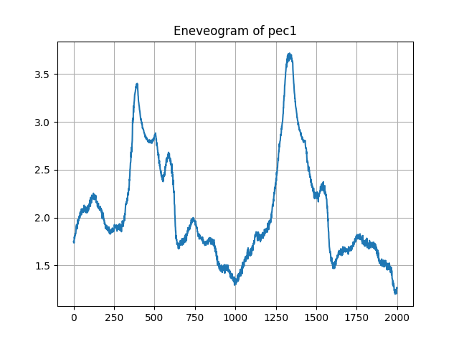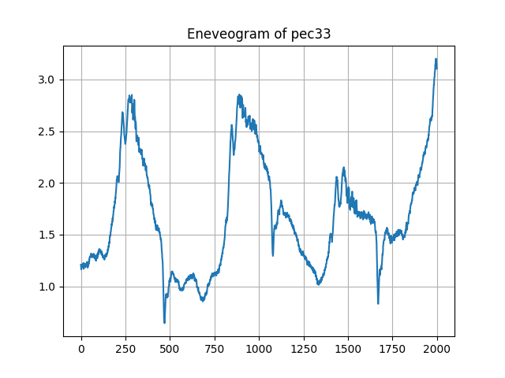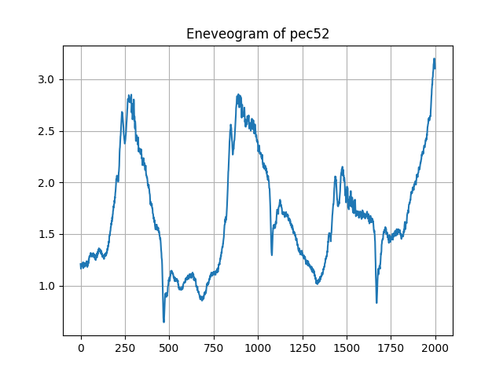

**Observations:**

The envelogram using complex demodulation by Sarkady is a technique used to extract the envelope of a modulated signal, such as a cardiac signal. To extend the procedure to average the envelograms over several cardiac cycles using the ECG as the trigger, we can follow the steps below:

1. Extract the ECG signal: Use an ECG signal as the trigger to identify the start and end of each cardiac cycle. We can use standard ECG processing techniques to extract the ECG signal.
2. Divide the cardiac signal into segments: Use the ECG signal to divide the cardiac signal into segments, with each segment corresponding to one cardiac cycle.
3. Apply the complex demodulation technique: Apply the complex demodulation technique to each segment to extract the envelope of the modulated signal for each cycle.
4. Average the envelograms: Once the envelope of the modulated signal has been extracted for each cycle, average the envelograms over several cardiac cycles to obtain a smoother and more accurate estimate of the envelope.

To handle the variations in the duration (number of samples) of the signals from one beat to another, we can use interpolation techniques to ensure that each segment has the same length before applying the complex demodulation technique. One common interpolation technique is linear interpolation, which involves fitting a straight line between two points and estimating the value of the signal at any point between them based on the slope of the line. Alternatively, we could use a spline interpolation method which can give a smoother estimate.

**Question 3**

The signal in the file emg_dog2.mat was recorded from the crural diaphragm of a dog using fine-wire electrodes sewn in-line with the muscle fibers and placed 10mm apart. The signal represents two cycles of breathing, and has been sampled at 10 kHz.

Write a Python program to perform full-wave rectification (absolute value) or half wave rectification (threshold at zero, with the mean value of the signal being zero). Apply a low pass Butterworth filter of order eight and cut off frequency in the range 10 to 20 Hz to the result. Analyse and evaluate the results with the two methods of rectification and at least two different low pass cutoff frequencies. Compare the results with the envelope provided in the emg_dog2_env.mat.

**Outputs**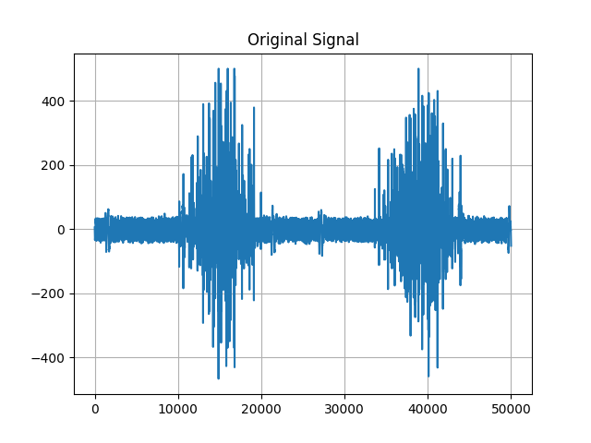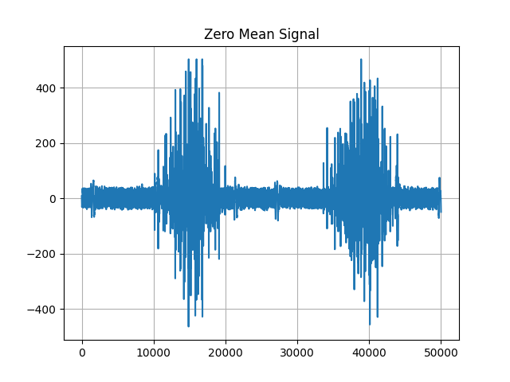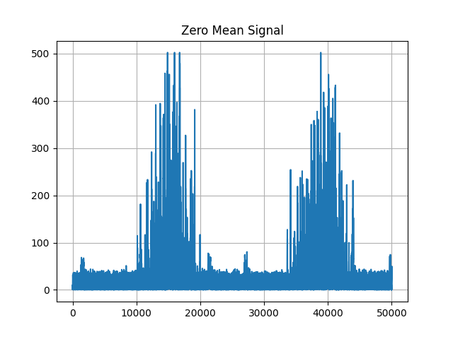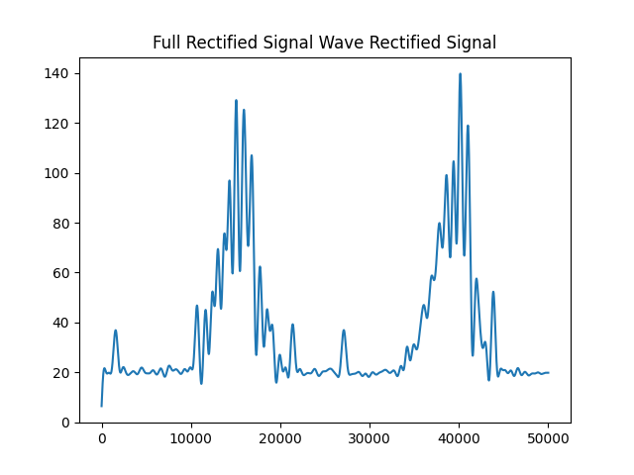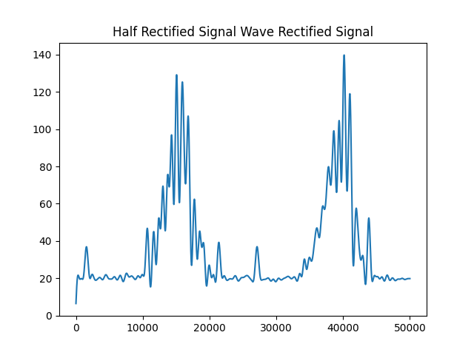

**Observations**

1. With decrease the cutoff frequency smoothness increases
2. Both the half wave rectified and full wave rectified signal gives the same result because in the signal given both the +ive part and –ive part is almost symmetric, and hence after passing through the low pass filter the output become almost same.